Project Plan

E-Commerce website

|  |
| --- |
| **Date : 28 feb. 2023** |
| **Version : 0.1** |
| **State : Draft** |
| **Author : Evaldas Drasutis** |

Version history

|  |  |  |  |  |
| --- | --- | --- | --- | --- |
| **Version** | **Date** | **Author(s)** | **Changes** | **State** |
| 0.1 | 28 feb. 2023 | **Evaldas,** | Initial draft |  |
|  |  |  |  |  |

**Distribution**

|  |  |  |
| --- | --- | --- |
| **Version** | **Date** | **Receivers** |
| 1 | 28-02-2022 | Erik van der Schriek |
|  |  |  |

Contents

1. Project assignment 4

1.1 Context 4

1.2 Goal of the project 4

1.3 Scope and preconditions 4

1.4 Strategy 5

1.5 Research questions and methodology 6

1.6 End products 6

2. Project organization 8

2.1 Stakeholders and team members 8

2.2 Communication 8

3. Activities and time plan 9

3.1 Phases of the project 9

3.2 Time plan and milestones 9

4. Testing strategy and configuration management 11

4.1 Testing strategy 11

4.2 Test environment and required resources 11

4.3 Configuration management 11

5. Finances and risk 12

5.1 Project budget 12

5.2 Risk and mitigation 12

# Project assignment

## Context

Shopping has become an online hobby where people can order items from the comfort of their home. Website would allow users to purchase any household items that they would desire.

In this project, I will design and develop an e-commerce website using microservices architecture and cloud services. Our goal is to create a scalable, flexible, and reliable platform that can handle increasing traffic, sales, and product offerings. We will use a cloud provider such as AWS or Microsoft Azure to build and deploy the microservices, including the database, storage, compute, and networking components. Each microservice will perform a specific function, such as product search, shopping cart management, payment processing, or order tracking, and will be integrated using a service-oriented architecture (SOA) approach.

* I’ll buy comes with product managing system that allows administrators to manage existing products.
* Search system
* Purchasing system
* Notification system
* Order tracking

## Goal of the project

The primary goal to the project is goal is to create an e-commerce website that is scalable, flexible, and reliable, with microservices and cloud services that can be easily integrated and modified to meet the changing needs of the business and customers. This approach can help to improve the website's performance, reduce maintenance costs, and enhance the customer experience.

Longer-term goals are:

* Providing purchase services that are secure and authenticated.
* Maintainable architecture to make the application secure.
* Implementation of security measures to protect customer data and prevent fraud.
* Implementation of performance optimization techniques to ensure fast and reliable website performance.

## Scope and preconditions

|  |  |
| --- | --- |
| **Inside scope:** | **Outside scope:** |
| 1. Logging in with role-based permissions | 1. Live user testing |
| 1. User friendly UI | 2 High fidelity prototypes |
| 1. Cloud services | 3 Any legal or regulatory compliance requirements that are specific to the business or industry |
| 4 Ability to set amount of testing a strategy | 4 The use of Artificial Intelligence |
| 5 Documentation of the design, architecture, and implementation details | 5 Design and development of the business's branding, logos, and marketing materials |

**Tools & Technologies**

Figma will be used to create structural research and designs for the UI of the application. In Google Drive, all the project-related documents are written and maintained.

The application will be using JavaScript in the framework ReactJS for the Frontend and Java Spring Boot for the Backend.

Additional software stack might be added with following iterations when I will be researching feature implementation.

**The essential stack :**

* Java – Programming language
* Spring Boot – Back-end integration framework for building microservices quickly.
* React – JavaScript library for building user interfaces specifically for single-page applications
* Docker / Kubernetes – Open-source containerization platform for packaging applications into containers.
* Cloud platforms (Azure, AWS, GCP, OpenShif, Netlab) – Web Cloud service
* Unit testing framework (JUnit) – repeatable automated testing for Java applications
* MUI (Material UI) – React UI library
* Next.js – React full-stack framework for developing single page JavaScript applications.
* Load Testing (JMeter)

## Strategy

Throughout this semester, I will be following a scrum agile approach that consists of 5 sprints. Each sprint will be divided into 3 weeks of work. First week will be used for analyzing the problem, second researching for the problem, lastly applying the research and providing a solution to a problem. This solution will be applied to gain the most accurate results for our research.

## Research questions and methodology

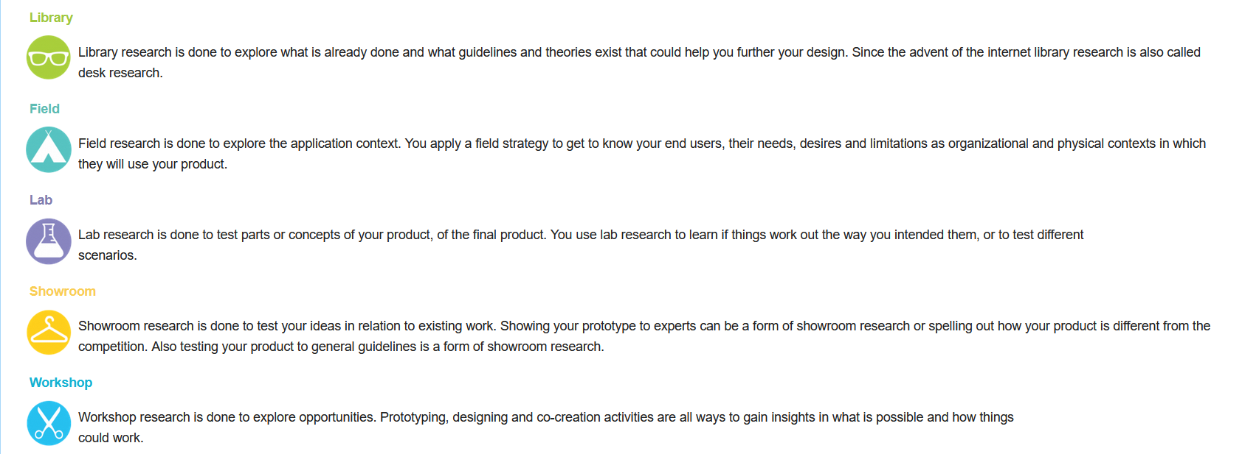

Main question:

How are cloud services and microservices applied in software and business models?

Initial questions that should be researched further based upon main requirements:

1. What is cloud, and how does it work?
2. How will I set up cloud services?
3. How to apply cloud services in REST API?
4. How cloud services effect business?
5. How cloud services work with docker?
6. What optimizations would allow the software to run fast?
7. How would cloud services work in an enterprise software architecture?
8. How to determine the best performing settings?

## End products

**Project plan:** The project plan will outline all the essential elements of the project, such as the

stakeholders, scope, deliverables, timelines, communication and risks.

**Research document:** The research document investigates the research questions using the DOT-Framework methodology.

**User interface (UI):** User interface provides the ability to monitor and change trading strategy settings.

**E-commerce backend:** E-commerce API responsible for applications features

**Presentation:** The presentation will showcase the process and results of the project.

**Transfer manual:** Manual for setting up the cloud environment.

# Project organization

## Stakeholders and team members

|  |  |  |  |
| --- | --- | --- | --- |
| **Name** | **Abbreviation** | **Role and functions** | **Availability** |
| *Erik van der Schriek* | *E. van der Schriek* | *Course developer, Technical teacher & Stakeholder* | *Available at TQ4/ TQ5 on Monday and Thursday morning (09:00 to 12:00)*  *When is the person available for your project (define this in the way most relevant for your project, e.g., which days are available, the amount of time, or in which phase of the project).* |
| *Gerard Elbers* | *G. Elbers* | *Teacher* | *Available at TQ4/ TQ5 on Monday and Thursday morning (09:00 to 12:00)* |
| *Maja Pesic* | *M. Pesic* | *Teacher, Technical teacher* | *Available at TQ4/ TQ5 on Monday and Thursday morning (09:00 to 12:00)* |
| *Evaldas Drąsutis* | *E. Drąsutis* | *Student* | *Monday, Tuesday, Wednesday, Thursday* |

## Communication

The meetings regarding the project and its process will take place both in person and online. The discussion for the project will be held at university R10 at a specific time. Whereas online meeting will be organized using Microsoft Teams to communicate any issues or project milestones. Sprint goals are set in the SCRUM boards in Jira, which I will showcase during the Sprint deliveries.

# Activities and time plan

## Phases of the project

For this project, I will be following the Scrum methodology to ensure fast and efficient progress. The project will be divided into sprints, with each sprint lasting three weeks. During each sprint, I will tackle the required features by creating issues that need to be resolved. Before starting work on each issue, I will spend some time researching and analyzing it to fully understand what needs to be done and how it can be approached.

To determine the estimated difficulty and time required for each issue, I will evaluate them and assign a number of points based on their complexity. If needed, I can seek clarification or guidance from other team members or teachers to ensure that I am on the right track.

Throughout the project, I will rely on the Scrum methodology to ensure that everything is progressing smoothly and efficiently. This approach will help me to stay focused and on track and will help me to deliver a high-quality end product within the specified timeframe.*Graphical user interface, application
*

## Time plan and milestones

In this section I will describe my projects sprint phasing and the initial deliverables for the particular sprint.

|  |  |  |  |
| --- | --- | --- | --- |
| **Sprint** | **Phasing** | **Start date** | **Finish date** |
| 1 | - Kick-off, project introduction  - Analyze project, functional requirement set up  - Initial project plan draft | Mar 6 | Mar 26 |
| 2 |  | Mar 27 | Apr 16 |
| 3 |  | Apr 27 | May 14 |
| 4 |  | May 15 | Jun 4 |
| 5 |  | Jun 5 | Jun 18 |
| Final |  | Jun 19 | Jun 25 |

# Testing strategy and configuration management

## Testing strategy

To comply with the learning outcomes, I will be using load testing to identify how effective the developed software is. The critical code paths will be tested using unit tests. The code will have automated quality testing with use of SonarQube.

## Test environment and required resources

The image below describes how the testing environment should handle testing in the development and production environments. Detailing that if the static tests are compliant the code will be delivered to the desired environment.

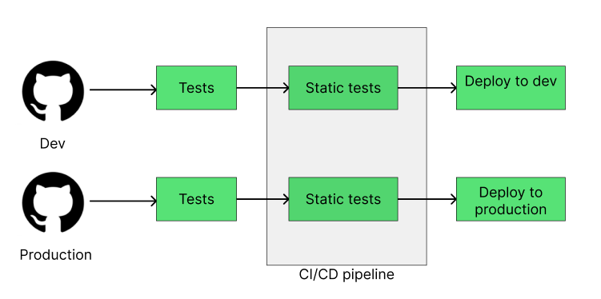

## Configuration management

Through the projects' development cycle, I will depend on using GIT repositories as my version control manager. Which should allow us to surveil the software quality and. Allowing me to work on the project simultaneously and with CI/CD pipelines I will be able to see if the software is working passing the set tests.

# Finances and risk

## Project budget

The software in question that is being developed indicates that during this project I will be working with applications that handle funds. This requires that I would be aware of high-risk situations when handling money transactional issues. Making several features is crucial to the software development. Such as: Security, Financial statuses, Transactions.

For the duration of the project, I will not be funded to obtain license to cloud servers, and I will be relying on open-source examples.

## Risk and mitigation

|  |  |  |
| --- | --- | --- |
| **Risk** | **Prevention activities** | **Mitigation activities** |
| 1. Code issues | Doing review sessions with teachers | Coming back to the issue in other sprints |
| 1. Low productivity & scope creep | Setting clear sprint goals. Taking smaller tasks to pace yourself. | Communicate existing problems to motivate the productivity |
| 1. Cost overruns | Optimizing the amount of separate microservices | Defining best setting for scaling a cloud software |
|  |  |  |